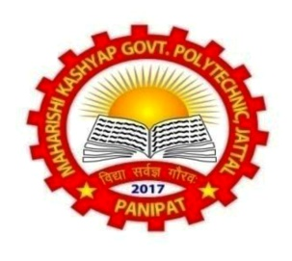
INVITATION
Web: gpjattal.ac.in
Alumni E mail:alumnigpjattal@gmail.com

We with enormous pleasure, the all Alumni Along with the students and staff of

Cordially invites you to the

When you can reconvene with your Comrades, Fellows, Educators & Remembrance of your Alma mater
PATRON: Sh. Rajeev Narwal, Principal
Coordinator: Sh. Jasbir Singh, HOD
Co-Coordinator: Dr. Virender Yadav, Smt. Navneet Kaur
Date: 27th Feb, 2026 Time: 10:00 A.M. onwards
“Let’s celebrate everything that has correct and remained”
You are cordially invited to return to MK Govt. Polytechnic, Jattal, Panipat

Batch Wise Introduction Refreshment Lunch Vote of Thanks
Branch Wise Coordinators
Sr. No. | Branch | Contact No.
Smt. Navneet Kaur | Chem. Engg. | 9812541070 | Dear Alumnus,  Time to think back, as your memories get year older, It’s time to reflect and recall the past. The enjoyable days you spent here, as time passes, we part ways. Spend a day missing everything you missed.
Smt. Kanika Bajaj | Comp. Engg. | 9812687080
Sh. Waseem | Elect. Engg. | 9458217248
Sh. Harish | Mech. Engg. | 8950801710
Smt. Sunita Devi | Textile Tech. | 9896965126
Registration Link: | https://forms.gle/5E2pS6apkPQgxJjP8

Regards,
M.K. Govt. polytechnic
Jattal, Panipat

